John Ye

[Company name]  [Company address]

[Document title]

|  |  |  |  |
| --- | --- | --- | --- |
| Name of Student | Kevin Wen | ID | 18549 |

**Assessment – Research and Questioning**

Contents

Instructions: 1

Business Scenario 1

Task 1: Determine support areas 2

Task 2: Identify stakeholders 2

Task 3: Develop support procedures 2

Task 4: Assign Support Personnel 2

Task 5: Short Answer Questions 3

Task 6: Multiple Choice Questions 3

Search Index 8

# Instructions:

This is an individual assessment. Answer all the questions on the document provided by your Trainer.

***Duration:***

Trainer will set the duration of the assessment.

# Business Scenario

D&K Books Pty Ltd is a bookstore owned by Mr. Dean Kerr. The business occupies two levels of an office building connected by escalators and lifts. D&K Books employs approximately six sales staff, one operation manager, two administrative officers, a bookkeeper and a marketing manager. They have an Ethernet network consisting of ten PCs (Intel I3 Desktop cloned), two switches, a router and three printers. They use the QuickBooks software to manage their entire business, including sales, inventory, ordering, accounts receivable, accounts payable, payroll and employee management. They also have two EFTPOS terminals one on each floor.

D&K Books has a Linux server that stores all of the data including the QuickBooks database. The server is backed up to tape regularly. They also have a website (hosted on an Australian ISP’s server, dynamic and static pages using asp.net) on which customers can browse the product catalogue and view current specials. They also lease a telephone system from Live Telecoms. The PABX (phone system) consists of a main switchboard and five remote phones with three incoming lines and a message-on-hold queue system.

# Task 1: Determine support areas

Identify information technology (HW and SW) and list the technology in use in D&K Books and consider the following:

* What sort of support does the technology require?
* Who is likely to provide this support?
* Does the support arrangement already exist?

Present your answer in a table such as the one below:

|  |  |  |  |  |
| --- | --- | --- | --- | --- |
| **Technology** | **Description** | **Support Required** | **Provider** | **Support Already exists? (Yes/No)** |
| QuickBooks Software | A software solution designed for tracking financial accounts, inventory, and GST compliance. | Includes customization, user training, periodic upgrades, bug fixes, and ongoing user support. | Available online through [Intuit Australia](https://www.intuit.com.au). | No |
| PC’s | Desktop computers powered by Intel i3 processors. | Includes hardware upgrades, repairs, troubleshooting, maintenance, networking setup, data backup, and system customization. | JB Hi-Fi | No |
| Server | A Linux-based server equipped with a tape backup system, with potential upgrades to a hard disk backup solution | Covers user account management, security policy implementation, folder access management, backups, software updates, and operating system patching. | Google Cloud | No |
| EFTPOS | Easy-to-use electronic payment system. | No additional support is needed, though vendor assistance is available if required. | Commbank | Yes |
| Telephone system | A cost-effective communication system. | Routine troubleshooting and system upgrades. | Vodazone | Yes |
| Website | A business website hosted on a low-cost hosting platform. | Involves regular content updates, hosting management, and monitoring for security issues | Domain.com | Yes |

# Task 2: Identify stakeholders

Identify stakeholders related in D&K Books system

Answer:

The stakeholders involved in the D&K Books system encompass all staff members, including the business owner, relevant managers, local employees, and remote employees. Specifically:

1. *Business Owner*: Responsible for decision-making and authorizing updates or modifications to the system.

2. *Manager*: Oversees the system to ensure it aligns with operational goals and business requirements.

3. *Local Employees*: Utilize the system for their routine tasks and workflows.

4. *Remote Employees*: Require secure and reliable access to the system for their responsibilities.

# Task 3: Develop support procedures

1. Describe one positive and one negative experience you have had when seeking assistance from a telecommunications company, an ISP or a computer supplier. Your experience may be via telephone, email or even voice recognition.
2. Using the experiences described above please answer the following questions.
   1. What support aspects were professional and/or unprofessional?
   2. How long did the support process take?
   3. Were the steps logical?
   4. Did they solve your problem?
   5. Was the call deflected to another area?

Answer:

1.

|  |  |  |
| --- | --- | --- |
| Type | Positive | Negative |
| Telephone | Quick and easy to get answers from support staff. | Lack proper documentation for reference. |
| Email | Clear communication with attached documents | Delayed response times |
| Go to company | Clear understanding through face-to-face interaction. | Time-consuming and costly due to travel |

2.

|  |  |  |
| --- | --- | --- |
| Items | professional | unprofessional |
| What support aspects | Friendly, attentive, and listens to concerns. | Lacks understanding of the customer's needs. |
| How long | Very quick and responsive | Excessive wait times |
| Steps logical | Clear and organized process. | Confusing and poorly structured steps |
| Solve | Effectively solved the issue. | Failed to resolve the problem |
| Another area | Properly redirected to an appropriate area and resolved | Ignored or mishandled, with no resolution |

# Task 4: Assign Support Personnel

Classify the following into soft skills and technical skills. Your answer should take the form of a table shown below.

|  |  |  |
| --- | --- | --- |
| **Skill** | **Soft skill** | **Technical skill** |
| A knowledge of Linux |  | X |
| The ability to work under pressure | X |  |
| The administration of Windows 2008 Server |  | X |
| The ability to formulate network and IT policies |  | X |
| The ability to write network documentation |  | X |
| The ability to give presentations | X |  |
|  | | |

# Task 5: Short Answer Questions

1. Explain the relationship between data, information and knowledge.

Answer:

* Data: Represents raw facts or figures without context (e.g., "25," "red").
* Information: Organized or processed data that provides context and meaning (e.g., "25 users logged in today").
* Knowledge: The application and interpretation of information to make informed decisions or solve problems (e.g., "25 daily logins indicate user engagement is consistent with our growth goals").What is quantitative data and how can you use it.

2. What is quantitative data and how can you use it.

Answer: Quantitative data is numerical information that can be measured or counted, such as revenue, temperature, or population size. It is used to quantify problems and answer questions like “how many” or “how often.” Researchers can use it to identify trends, measure performance, or make data-driven decisions

1. What is qualitative data and how can you use it.

Answer: Qualitative data is non-numerical and focuses on descriptions, characteristics, and qualities. It provides insights into behaviors, opinions, and motivations, often collected through interviews, focus groups, or observations. It is useful for understanding the "why" behind trends or phenomena, such as customer satisfaction or employee morale

1. Give an example of how quantitative and qualitative data can be used in conjunction with each other

Answer: In a customer feedback study, quantitative data might reveal that 80% of users are satisfied with a product. Qualitative data from interviews can explain why they are satisfied, such as appreciating the product's ease of use or design. Combining both types of data provides a complete understanding of user satisfaction

1. What sort of methods could you use to determine client requirements for a website design and key information sources?

Answer: Methods:

- Conducting client interviews or surveys.

- Organizing brainstorming sessions with stakeholders.

- Analyzing competitors' websites for features and design inspiration.

- Observing user behavior through usability testing or analytics of the current website.

Key Information Sources:

- Client-provided documentation or initial project briefs.

- Direct feedback from end-users or focus groups.

- Industry-specific standards or best practices.

1. Give some examples of client requirements for a website design

Answer:

* Design and Layout: Clean, user-friendly interface with consistent branding.
* Functionality:Responsive design, secure payment systems, or interactive features like live chat.
* Content: Well-structured pages with SEO-optimized text and multimedia elements.
* Performance:Fast load times and mobile optimization.
* Accessibility: Compliance with accessibility standards (e.g., WCAG).
* Integration: Links to social media platforms or third-party tools like CRM systems.

# Task 6: Multiple Choice Questions

1. Generally, how many points should a rating scale have?
   1. Five
   2. Four
   3. Ten
   4. Somewhere from 4 to 11 points

Comment: A rating scale typically ranges from 4 to 11 points, striking a balance between sensitivity and usability for respondents.

Web Refer: <https://brainly.in/question/31814012#:~:text=Answer,-2%20people%20found&text=Answer%3A,maintain%20too%20many%20response%20options>.

1. What is the problem(s) with this set of response categories to the question “What is your current age?” o 1-5 o 5-10 o 10-20 o 20-30 o 30-40
   1. The categories are not mutually exclusive
   2. The categories are not exhaustive
   3. Both a and b are problems
   4. There is no problem with the above set of response categories

Comment: Overlapping categories can cause confusion as they are not mutually exclusive, making data classification challenging.

Web Refer: <https://www.coursehero.com/file/p567ru8/What-is-the-problems-with-this-set-of-response-categories-to-the-question-What/>

1. You should mix methods in a way that provides complementary strengths and no overlapping weaknesses. This is known as the fundamental principle of mixed research.

a) True

b) False

Comment: Mixed research methods aim to combine qualitative and quantitative approaches, maximizing strengths and minimizing weaknesses.

Web Refer: <http://mcqsquestion.blogspot.com/2011/01/methods-of-data-collection.html>

1. According to the text, questionnaires can address events and characteristics taking place when?
   1. In the past (retrospective questions)
   2. In the present (current time questions)
   3. In the future (prospective questions)
   4. All of the above

Comment: Questionnaires can be used to collect information about past, present, and future events depending on research goals

Web Refer: <https://www.studocu.com/in/messages/question/7981173/questionnaires-can-address-events-and-characteristics-taking-place-whenain-the>

1. Which of the following are principles of questionnaire construction?
   1. Consider using multiple methods when measuring abstract constructs
   2. Use multiple items to measure abstract constructs
   3. Avoid double-barrelled questions
   4. All of the above e. Only b and c

Comment: Effective questionnaire design involves multiple methods to measure complex constructs while avoiding biased or unclear questions.

Web Refer: <http://www.analytictech.com/mb313/principl.htm>

1. Which of these is not a method of data collection?
   1. Questionnaires
   2. Interviews
   3. Experiments
   4. Observations

Comment: Experiments differ from direct data collection methods like interviews, questionnaires, and observations.

Web Refer: <https://www.icao.int/training/TNA/Documents/methods_for_data_gathering.pdf>

1. Secondary/existing data may include which of the following?
   1. Official documents
   2. Personal documents
   3. Archived research data
   4. All of the above

Comment: Secondary data comprises existing resources such as official documents, personal records, and archived research materials.

Web Refer: <https://careerfoundry.com/en/blog/data-analytics/what-is-secondary-data/>

1. An item that directs participants to different follow-up questions depending on their response is called a ____________.
   1. Response set
   2. Probe
   3. Semantic differential
   4. Contingency question

Comment: Contingency questions guide participants to follow-up questions based on their answers, customizing the survey flow.

Web Refer: <https://www.coursehero.com/file/p24t38q9/An-item-that-directs-participants-to-different-follow-up-questions-depending-on/>

1. Which of the following terms best describes data that were originally collected at an earlier time by a different person for a different purpose?

a) Primary data

* 1. Secondary data
  2. Experimental data
  3. Field notes

Comment: Secondary data refers to previously collected information used for new research purposes.

Web Refer: <https://www.toppr.com/ask/en-au/question/which-of-the-following-terms-best-describes-data-that-we-originally-collected-at-an-earlier#:~:text=Secondary%20data%20is%20the%20second,report%20is%20a%20secondary%20data>.

1. Researchers use both open-ended and closed-ended questions to collect data. Which of the following statements is true?
   1. Open-ended questions directly provide quantitative data based on the researcher’s predetermined response categories
   2. Closed-ended questions provide quantitative data in the participant’s own words
   3. Open-ended questions provide qualitative data in the participant’s own words
   4. Closed-ended questions directly provide qualitative data in the participants’ own words

Comment: Open-ended questions are ideal for collecting qualitative data, offering richer and more detailed responses in the participant's own words.

Web Refer: <https://www.chegg.com/homework-help/questions-and-answers/010-researchers-use-open-ended-closed-ended-questions-collect-data-following-statements-tr-q85410215>

1. Open-ended questions provide primarily ______ data.
   1. Confirmatory data
   2. Qualitative data
   3. Predictive data
   4. None of the above

Comment: Open-ended questions primarily generate qualitative data, capturing detailed, unstructured insights.

Web Refer: <https://www.nngroup.com/articles/open-ended-questions/>

1. Which of the following is true concerning observation?
   1. It takes less time than self-report approaches
   2. It costs less money than self-report approaches
   3. It is often not possible to determine exactly why the people behave as they do
   4. All of the above

Comment: While observation provides firsthand behavioral data, determining motives often remains challenging.

Web Refer: <https://www.cdc.gov/healthyyouth/evaluation/pdf/brief16.pdf>

1. Qualitative observation is usually done for exploratory purposes; it is also called ___________ observation.
   1. Structured
   2. Naturalistic
   3. Complete
   4. Probed

Comment: Naturalistic observation focuses on studying behavior in its usual setting for exploratory purposes.

Web Refer: <http://mcqsquestion.blogspot.com/2011/01/methods-of-data-collection.html>

1. When constructing a questionnaire, it is important to do each of the following except ______.
   1. Use "leading" or "loaded" questions
   2. Use natural language
   3. Understand your research participants
   4. Pilot your test questionnaire

Comment: Leading or biased questions can skew results and should be avoided during questionnaire construction.

Web Refer: <https://www.chegg.com/homework-help/questions-and-answers/constructing-questionnaire-important-following-except-understand-participants-give-questio-q113868556#:~:text=select%20your%20sample.-,Transcribed%20image%20text:,you%20will%20select%20your%20sample>.

1. Another name for a Likert Scale is a(n):
   1. Interview protocol
   2. Event sampling
   3. Summated rating scale
   4. Ranking

Comment: A Likert Scale, also known as a summated rating scale, combines responses to multiple items for measurement.

Web Refer: <https://en.wikipedia.org/wiki/Likert_scale#:~:text=Hence%2C%20Likert%20scales%20are%20often,are%20the%20most%20applicable%20methods>.

1. Which of the following is not one of the six major methods of data collection that are used by educational researchers?
   1. Observation
   2. Interviews
   3. Questionnaires
   4. Checklists

Comment: Checklists serve as tools within methods but are not standalone methods of data collection.

Web Refer: <https://www.jotform.com/data-collection-methods/>

1. The type of interview in which the specific topics are decided in advance but the sequence and wording can be modified during the interview is called:

a) The interview guide approach

* 1. The informal conversational interview
  2. A closed quantitative interview
  3. The standardized open-ended interview

Comment: The interview guide approach balances flexibility and focus, allowing questions to adapt while covering key topics.

Web Refer: <https://www.chegg.com/homework-help/questions-and-answers/ed-q14-type-interview-specific-topics-decided-advance-sequence-wording-modified-interview--q85410062>

1. Which one of the following in not a major method of data collection?
   1. Questionnaires
   2. Interviews
   3. Secondary data
   4. Focus groups
   5. All of the above are methods of data collection

Comment: The correlational method is an analysis technique rather than a data collection method.

Web Refer: <https://www.questionpro.com/blog/data-collection-methods/#:~:text=Some%20common%20data%20collection%20methods,about%20the%20study's%20subject%20matter>.

1. A question during an interview such as “Why do you feel that way?” is known as

a) Probe

* 1. Filter question
  2. Response
  3. Pilot

Comment: Probes are follow-up prompts designed to clarify or expand on participants’ responses during an interview.

Web Refer: <https://brainly.com/question/41354526#:~:text=Explanation%3A,a%20particular%20statement%20or%20belief>.

1. A census taker often collects data through which of the following?
   1. Standardized tests
   2. Interviews
   3. Secondary data
   4. Observations

Comment: Census takers often rely on interviews to collect demographic and other personal data.

Web Refer: <https://www.abs.gov.au/websitedbs/d3310114.nsf/home/Basic+Survey+Design+-+Samples+and+Censuses#:~:text=A%20census%20is%20a%20collection,census%20offers%20the%20best%20solution>.

1. The researcher has secretly placed him or herself (as a member) in the group that is being studied. This researcher may be which of the following?

a) A complete participant

* 1. An observer-as-participant
  2. A participant-as-observer
  3. None of the above

Comment: A complete participant is a researcher who fully integrates into the group being studied without disclosing their role.

Web Refer: <https://www.coursehero.com/file/p6fe0vsb/20-The-researcher-has-secretly-placed-him-or-herself-as-a-member-in-the-group/>

1. Which of the following is not a major method of data collection?
   1. Questionnaires
   2. Focus groups
   3. Correlational method
   4. Secondary data

Comment: The correlational method is an analytical approach, not a direct means of gathering data.

Web Refer: <https://www.indeed.com/career-advice/career-development/methods-of-data-collection>

1. Which type of interview allows the questions to emerge from the immediate context or course of things?

a) Interview guide approach

* 1. Informal conversational interview
  2. Closed quantitative interview
  3. Standardized open-ended interview

Comment: Informal conversational interviews adjust dynamically to the flow of the discussion.

Web Refer: <https://mcqmate.com/discussion/94662/which-type-of-interview-allows-the-questions-to-emerge-from-the-immediate-context-or-course-of-things>

1. When conducting an interview, asking "Anything else? What do you mean? Why do you feel that way?," etc, are all forms of:
   1. Contingency questions
   2. Probes
   3. Protocols
   4. Response categories

Comment: Probes are additional questions aimed at eliciting more detailed or explanatory responses.

Web Refer: <https://www.people.vcu.edu/~pdattalo/ReviewQsAns_609.htm>

1. When constructing a questionnaire, there are 15 principles to which you should adhere. Which of the following is not one of those principles?
   1. Do not use "leading" or "loaded" questions
   2. Avoid double-barrelled questions
   3. Avoid double negatives
   4. Avoid using multiple items to measure a single construct

Comment: Using multiple items for a single construct enhances the validity and reliability of a questionnaire.

Web Refer: <https://www.coursehero.com/file/p3chbuu/25-When-constructing-a-questionnaire-there-are-15-principles-to-which-you-should/>

1. A customer-based Service Level Agreement structure includes:
   1. An SLA covering all Customer groups and all the services they use
   2. SLAs for each service that are Customer-focused and written in business language
   3. An SLA for each service type, covering all those Customer groups that use that Service
   4. An SLA with each individual Customer group, covering all of the services they use

Comment: Customer-based SLAs define expectations in clear, customer-focused terms for specific services.

Web Refer: <https://www.proprofs.com/quiz-school/story.php?title=nzk3odazz2n8#:~:text=A%20customer%2Dbased%20Service%20Level%20Agreement%20structure%20includes%20an%20SLA,all%20the%20services%20they%20utilize>.

1. Which of the following best describes the goal of Service Level Management?
   1. To maintain and improve IT service quality in line with business requirements
   2. To provide IT services at the lowest possible cost by agreeing with Customers their minimum requirements for service availability and ensuring performance does not exceed these targets
   3. To provide the highest possible level of service to Customers and continuously improve on this through ensuring all services operate at maximum availability
   4. To ensure that IT delivers the same standard of service at the least cost

Comment: Service Level Management seeks to align IT service quality with business needs while maintaining efficiency.

Web Refer: <https://quizlet.com/388062886/itil-questions-brain-dump-flash-cards/>

1. The process to implement SLAs comprises of the following activities in sequence:
   1. Draft SLAs, catalogue services, review underpinning contracts and OLAs, draft SLRs, negotiate, agree

SLAs

* 1. Draft SLAs, review underpinning contracts and OLAs, negotiate, catalogue services,
  2. Review underpinning contracts and OLAs, draft SLAs, catalogue services, negotiate, agree SLAs
  3. Catalogue services, establish SLRs, review underpinning contracts and OLAs, negotiate service levels, agree SLAs

Comment: The SLA implementation process typically starts with service cataloging, followed by setting expectations and negotiating agreements.

Web Refer: <https://www.cram.com/flashcards/itil-foundation-v3-questions-needing-review-3333301>

1. Which of the following is an example of a service level agreement (SLA) between an information systems support unit and a research unit in the laboratories of a large company?
   1. The maximum response time to get the system operational should it fail.
   2. The minimum ‘up-time’.
   3. The types of information that will be provided as standard.
   4. All of the above.

Comment: Comprehensive SLAs include key details such as response times, uptime guarantees, and standard information provisions.

Web Refer: <https://www.coursesidekick.com/information-systems/1160526>

1. Some organisations bring a degree of formality to the internal customer concept by encouraging (or requiring) different parts of the operation to agree on:

a) Internal service agreements

* 1. Service level agreements
  2. Formal provision agreements
  3. Delivery agreements

Comment: Internal SLAs formalize the expectations and responsibilities of different departments within an organization.

Web Refer: <https://www.business.qld.gov.au/running-business/marketing-sales/sales/communicating-effectively>

My support website URL: <https://kevinwen620.github.io/ECBR18549/>

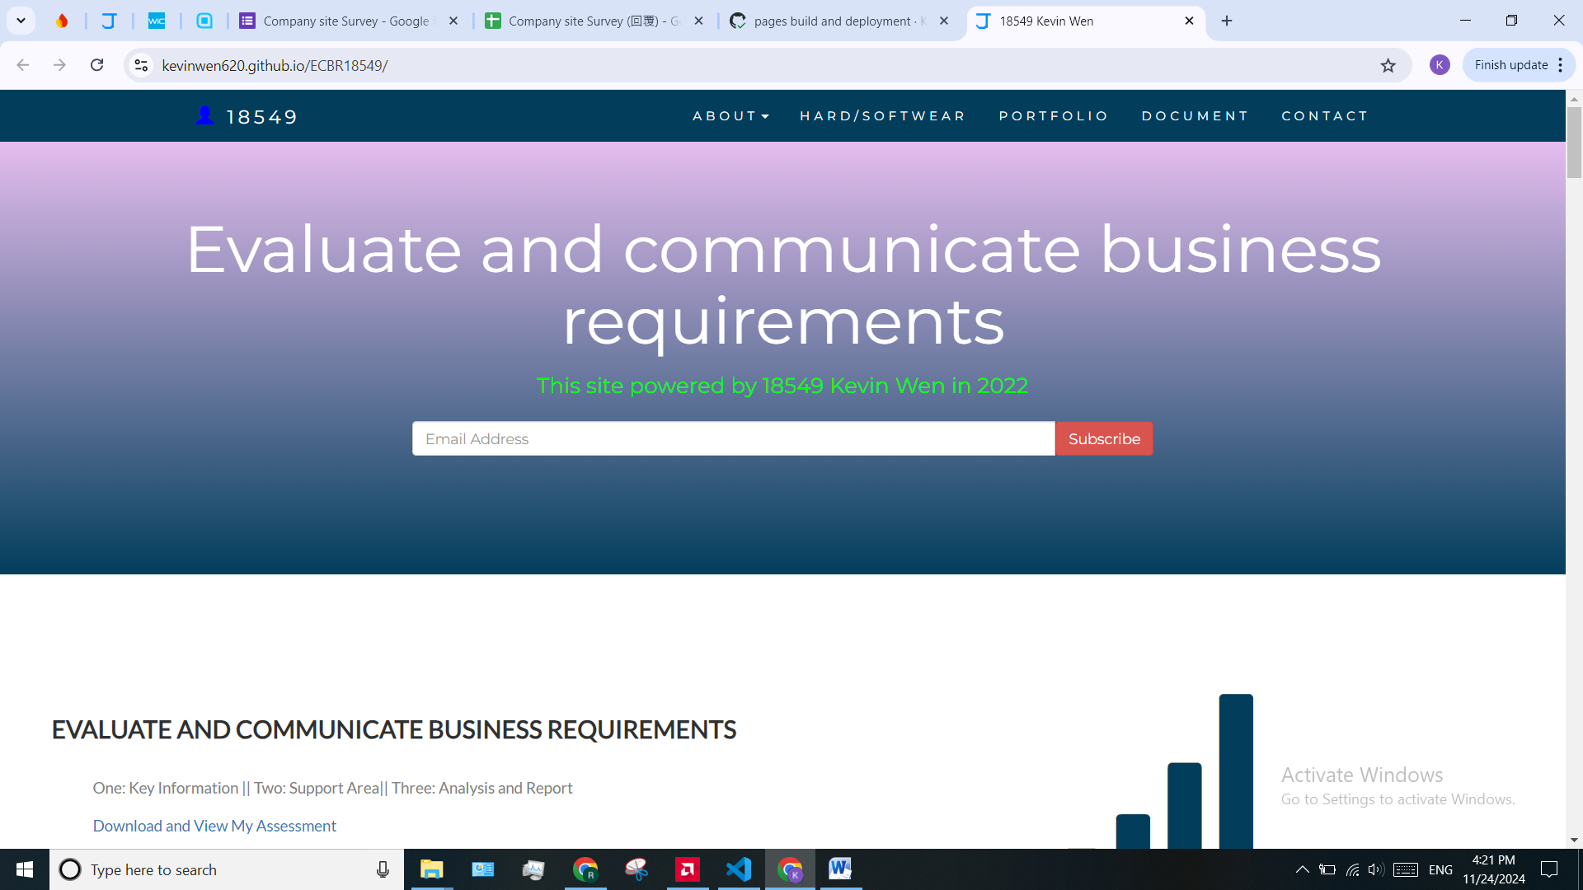

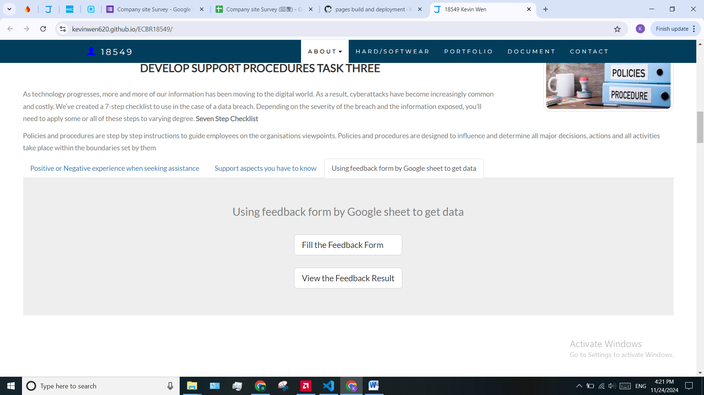

# Search Index